**ROOT CAUSE** ANALYSIS

* RCA is a structured approach to identifying and addressing the underlying causes of problems or issues within an organization

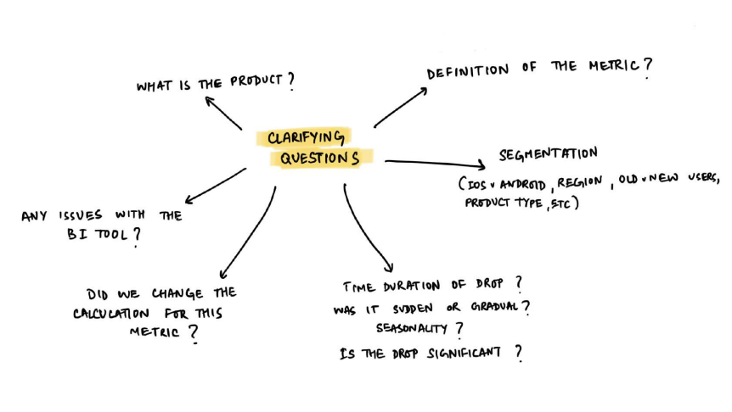

* Understand the complete workflow wrt to KPI like opening app ,signing in ,go to home page ,browse etc ,end 2 end
* **Internal Factors** - Internal factors refer to elements within an organization that are directly under its control

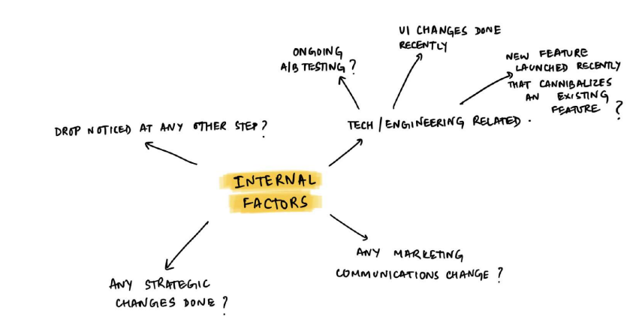

* **External Factors** : external factors refer to elements outside the immediate system or process that can impact the problem being analyzed. These factors may include:
* **Market changes**: Such as the emergence of new competitors or economic shifts.
* **Regulatory changes**: New laws and regulations that affect the system.
* **Technological developments**: Innovations that render existing products or processes obsolete.
* **Geopolitical factors**: Social unrest, conflicts, or other global events

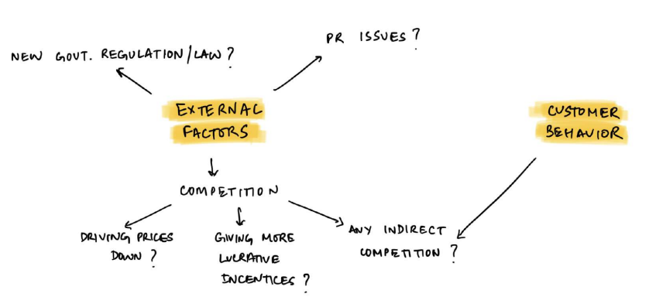

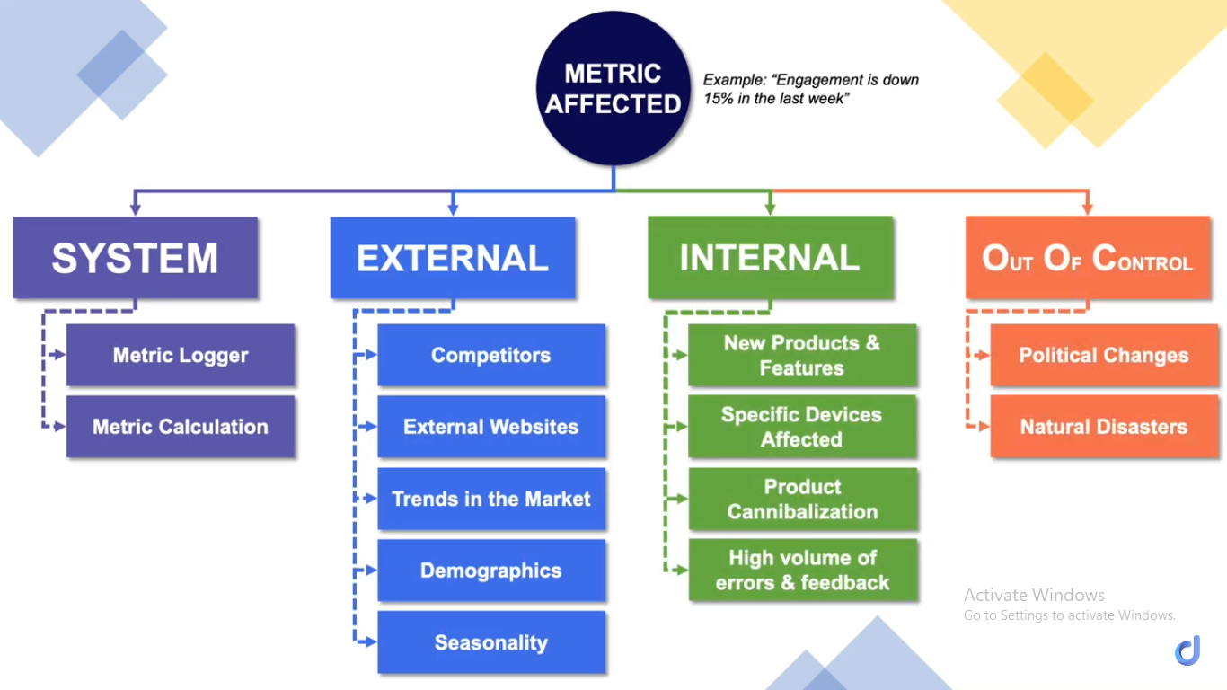

**Product cannibalization**, also known as market cannibalization, occurs when a company’s new product displaces an existing one. [In other words, it reduces purchases of an older product and eats away at the company’s own sales](https://www.investopedia.com/terms/m/marketcannibilization.asp)

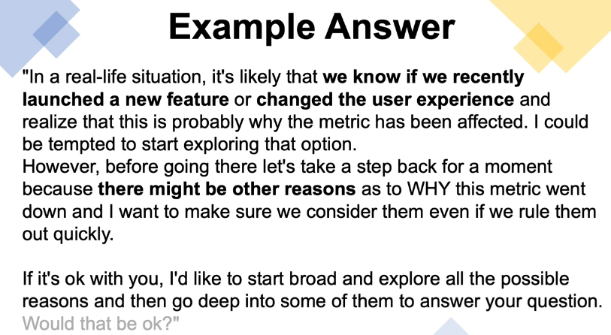

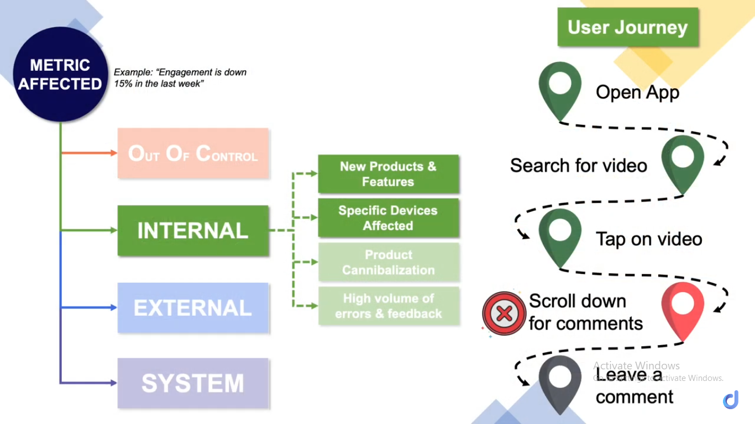

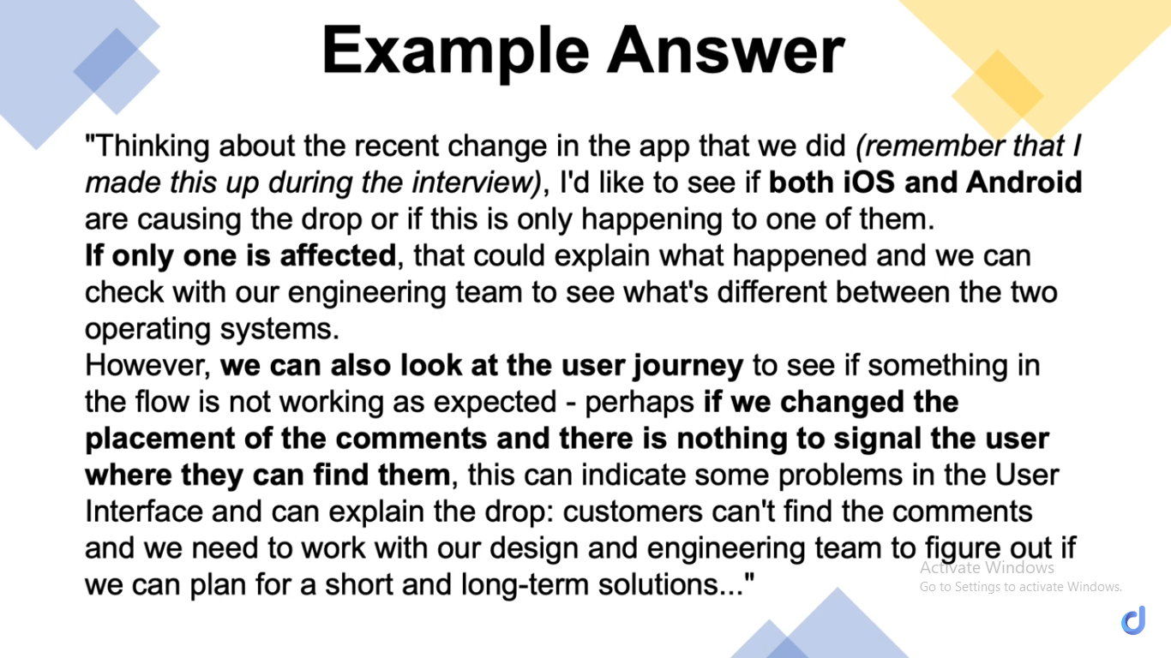

* General statistics
  + India population is 1.42 billion ,seniors(60+) ~ 10% , adults (25-59)~ 60% , young people (15-24) ~ 20%
  + India’s rural-urban distribution is approximately 64% rural and 36% urban.